Lambda Equation:
interface MyInter
{
void sayHello();
}

class Demo
{
public static void main(String args[ ])
{
MyInter m= ( ) -> { System.out.println("Hello"); };
m.sayHello();

MyInter n= ( ) -> { System.out.println("Hiii"); };
n.sayHello();
}
}
interface MyInter
{
void sayHello();
}

class Demo
{
public static void main(String args[ ])
{
String uname="Satish";

MyInter m= ( ) -> { System.out.println("Hello " + uname); };
m.sayHello();
}
}
interface MyInter
{
void sayHello(String uname);
}

class Demo
{
public static void main(String args[ ])
{
MyInter m= (s) -> { System.out.println("Hello " + s); };
m.sayHello("Uma");
}
}
interface MyInter
{
String sayHello(String uname);
}

class Demo
{
public static void main(String args[ ])
{
MyInter m= (s) -> "Hello " + s;
String result=m.sayHello("Uma");
System.out.println(result);
}
}
interface MyInter
{
String sayHello(String uname);
}

class Demo
{
static void format(MyInter m, String uname)
{
String result=m.sayHello(uname);
System.out.println(result);
}

public static void main(String args[ ])
{
MyInter obj1= (s) -> "Hello " + s;
format(obj1, "Uma");

MyInter obj2= (s) -> "Hiiii " + s;
format(obj2, "Uma");
}
}
import java.util.*;

class Demo
{
public static void main(String args[ ])
{
ArrayList<String> list=new ArrayList<String>();

list.add("Satish");
list.add("Anil");
list.add("Uma");
list.add("Saket");
list.add("Vijay");

list.forEach( (str) -> {System.out.println(str);} );
}
}
import java.util.*;
import java.util.function.*;

class Demo
{
public static void main(String args[ ])
{
ArrayList<String> list=new ArrayList<String>();

list.add("Satish");
list.add("Anil");
list.add("Uma");
list.add("Saket");
list.add("Vijay");

Consumer<String> fun= (str) -> { System.out.println(str);};
list.forEach(fun);
}
}
import java.util.*;
import java.util.function.*;

class Demo
{
public static void main(String args[ ])
{
ArrayList<Integer> list=new ArrayList<Integer>();

list.add(100);
list.add(200);
list.add(300);
list.add(400);
list.add(500);

Consumer<Integer> fun= (num) -> { System.out.println(num);};
list.forEach(fun);
}
}
import java.util.*;
import java.util.function.*;

class Demo
{
public static void main(String args[ ])
{
ArrayList<Integer> list=new ArrayList<Integer>();

list.add(100);
list.add(200);
list.add(300);
list.add(400);
list.add(500);

Consumer<Integer> fun= (num) -> { System.out.println(num.intValue());};
list.forEach(fun);
}
}
import java.util.*;
import java.util.function.*;

class Demo
{
public static void main(String args[ ])
{
ArrayList<Integer> list=new ArrayList<Integer>();

list.add(100);
list.add(200);
list.add(300);
list.add(400);
list.add(500);

Consumer<Integer> fun= (num) -> { System.out.println(num.intValue() + 5);};
list.forEach(fun);
}
}
import java.util.*;
import java.util.function.*;

class Demo
{
public static void main(String args[ ])
{
HashSet<Integer> list=new HashSet<Integer>();

list.add(100);
list.add(200);
list.add(300);
list.add(400);

Consumer<Integer> fun=(num) -> {System.out.println(num);};
list.forEach(fun);
}
}
o/p:
400
100
200
300
import java.util.*;
import java.util.function.*;
class Demo
{
public static void main(String args[ ])
{
HashSet<Integer> set=new HashSet<Integer>();
set.add(100);
set.add(200);
set.add(300);
set.add(400);
Consumer<Integer> fun=(num) -> {System.out.println(num.intValue());};
set.forEach(fun);
}
}
o/p:
400
100
200
300
_________________________________________________
import java.util.*;
import java.util.function.*;
class Demo
{
public static void main(String args[ ])
{
HashMap<String, Integer> map=new HashMap<String, Integer>();
map.put("Pune", 30);
map.put("Mumbai", 35);
map.put("Chennai", 32);
map.put("Kolkata", 33);
BiConsumer<String, Integer> fun=(key, value) -> {System.out.println(key + " " + value);};
map.forEach(fun);
}
}
o/p:
Chennai 32
Pune 30
Kolkata 33
Mumbai 35
Cloneable interface :
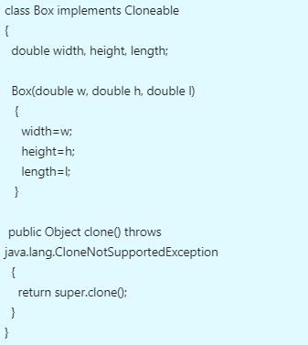
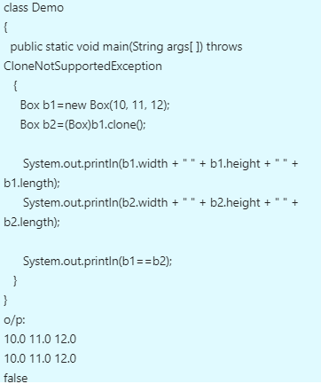
finalize method :
class Box
{
double width, height, length;

Box(double w, double h, double l)
{
width=w;
height=h;
length=l;
}

protected void finalize()
{
System.out.println("finalize method called");
}
}

class Demo
{
public static void main(String args[ ])
{
Box b1=new Box(10, 11, 12);
b1=null;
System.gc();
}
}

